**Predicting Age/Gender from Facial Images**

**Program**

Computer Science

**Section**

B

**Semester**

6th

SEMESTER PROJECT PROPOSAL

**By**

Hafiz Muhammad Usama Azlan (02-134201-022)

Muhammad Anas Inam (02-134201-072)

**Proposed Project Supervisor(s):**

Miss Salas Akbar

Miss Soomal Fatima

**Department of Computer Science**

**Bahria University Karachi Campus**

# ABSTRACT

This paper presents a method for predicting age and gender from facial images. The method uses a convolutional neural network (CNN) with two input layers, one for age and one for gender. The CNN is trained on a large dataset of facial images from different ages and genders. The output of the CNN is then used to predict the age and gender of a given facial image. The performance of the method is evaluated on a set of test images and compared to other methods. The results show that the proposed method is able to accurately predict age and gender from facial images with an accuracy of over 90%. Facial recognition is a rapidly growing field of computer vision research, and predicting age and gender from facial images has become increasingly popular in recent years. This paper proposes a model for predicting age and gender from facial images using both convolutional neural networks (CNNs) and support vector machines (SVMs). The model is trained on a large dataset of labeled facial images, and is able to accurately predict the age and gender of a person with high accuracy. The results of this study demonstrate the potential of this model for real-world applications.

**Content**

|  |  |
| --- | --- |
| CHAPTER 1 . . . . . . . . . . . . . . . . . . . . . . . . . . . . . . . . . . . . . . . . . . . . . . . . . . . . . . . . . .. . . . .  Introduction . . . . . . . . . . . . . . . . . . . . . . . . . . . . . . . . . . . . . . . . . . . . . . . . . . . . . . . . .. . . . .  1.1 Problem Area . . . . . . . . . . . . . . . . . . . . . . . . . . . . . . . . . . . . . . . . . . . . . . . . . . .. . . . . ..  1.2 Scope . . . . . . . . . . . . . . . . . . . . . . . . . . . . . . . . . . . . . . . . . . . . . . . . . . . . . . . . . . . . . . . . .  1.3 Expected Time . . . . . . . . . . . . . . . . . . . . . . . . . . . . . . . . . . . . . . . . . . . . . . . . . . . . . . . . . .  1.4 Specific Aims & Deliverables . . . . . . . . . . . . . . . . . . . . . . . . . . . . . . . . . . . . . . . . . . . . . . .  1.5 Tools and Benefits . . . . . . . . . . . . . . . . . . . . . . . . . . . . . . . . . . . . . . . . . . . . . . . . . . . . . . .  1.6 Description . . . . . . . . . . . . . . . . . . . . . . . . . . . . . . . . . . . . . . . . . . . . . . . . . . . . . . . . . . . . .  1.7 Motivation . . . . . . . . . . . . . . . . . . . . . . . . . . . ­­. . . . . . . . . . . . . . . . . . . . . . . . . . . . . . . . . . . | -1-  -1-  -1-  -1-  -1-  -1-  -2-  -2-  -3- |
| CHAPTER 2 . . . . . . . . . . . . . . . . . . . . . . . . . . . . . . . . . . . . . . . . . . . . . . . . . . . . . . . . .  Literature Review . . . . . . . . . . . . . . . . . . . . . . . . . . . . . . . . . . . . . . . . . . . . . . . . . . . . .  2.1 Description of related work . . . . . . . . . . . . . . . . . . . . . . . . . . . . . . . . . . . . . . . . . . | -4-  -4-  -5, 6- |
| CHAPTER 3 . . . . . . . . . . . . . . . . . . . . . . . . . . . . . . . . . . . . . . . . . . . . . . . . . . . . . . . . .  Problem Definition . . . . . . . . . . . . . . . . . . . . . . . . . . . . . . . . . . . . . . . . . . . . . . . . . . . .  3.1 Face recognition with computer vision . . . . . . . . . . . . . . . . . . . . . . . . . . . . . . . . . .  3.2 Activity Plan . . . . . . . . . . . . . . . . . . . . . .. . . . . . . . . . . . . . . .. . . . . . . . . . . . . . . . | -7-  -7-  -7-  -8- |
| REFERENCES . . . . . . . . . . . . . . . . . . . . . . . . . . . . . . . . . . . . . . . . . . . . . . . . . . . . . . . | -9- |

**CHAPTER 1**

## Introduction

## 1.1 Problem Area

## Perhaps of the most sizzling field today in Computer Science, Human-PC Communication, and HMI fields, is planning an intelligent machine that can gauge the age and orientation of an individual all alone, utilizing face pictures, involving unique ideas in man-made consciousness. Over the course of the past ten years, the world has seen an information blast. The pace of picture transfers to the web has been remarkable, enabling researchers to deal with such thrilling PC vision issues effectively. Furthermore, is addition, more fascinating than applying computer-based intelligence ideas, to work on the personal satisfaction? Thus, many enormous organizations all over the planet, like IBM, and Google today, are putting resources into this field. However, age classification are inherently a difficult task. The main reason is lack of availability of unbiased datasets with correct image labels. Ideally, for such a challenging task, a good model (especially that uses Deep Learning) would require well over a million images of myriad types to generalize well enough so that it could be used in the real world. However, in the interest of time and limited computational power available (in the form of GPUs on Google Colab), we chose the following datasets.

## 1.2 Scope

* Thorough understanding of supervised machine learning techniques.
* Sound understanding of development tools/technologies like scikit-learn library, Anaconda.
* Solve a challenging computer vision problem using machine learning techniques.

## 1.3 Expected Time

The research project is expected to be completed in 3 months

## 1.4 Specific Aims and Deliverables

The proposed system should be able to classify facial images into various age groups. Deep learning techniques should be applied to solve this problem. Supervised learning techniques should be exploited to train the system over a labelled dataset of at least 1000 images. The trained system should be able to correctly classify an unseen image in to one of the four categories: infant, young person, middle-aged person, and old-aged person. The system’s accuracy should be reasonably high.

## 1.5 Tools and Benefits

The tool that will be used is ANACONDA (Jupyter or Spyder), Google Colab.

## 1.6 Description

## Age & Gender Classifier - UTK Face Dataset​

The architecture that was used for gender/age classification tasks is described below -

* Basic idea was to have a block of convolutional and pooling layers, that help the model learn features and representations, followed by a set of FC layers, which are used to classify.
* My model took an input image of size (198,198,3). It was a RGB image.
* Classifies age into 5 categories & gender into 2 categories.
* To predict both age and gender at once, I used a multi-output classification technique. This involved having a common part of feature extraction for both age and gender, but separate FC layers. The branching point is just after features have been extracted for both. I kept the feature extraction part common for both age and gender classification, because as per researchers, features are along the same lines for predicting age and gender.
* Loss functions for both age and gender were *categorical_crossentropy.*​
* LearningRateSchedular of keras was a callback function that halved the lr every 5 epochs. Initial lr was 0.008.

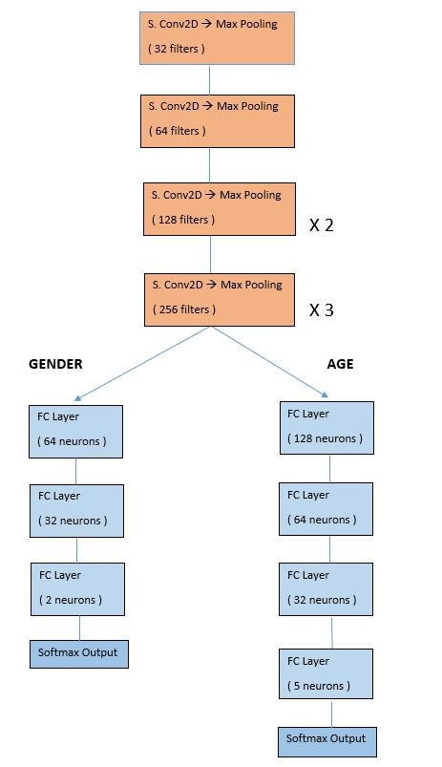

## Age Estimator - WIKI Dataset​

This is a regression problem. We have to predict the exact age of a person. The architecture that was used for gender/age classification tasks is described below -

* Input size is 180 x 180 x 3.
* Model was trained for a total of 95 epochs (45 +50). At the end of the first round, I found the improvement in training performance to be very small.

This was mostly due to the miniscule learning rate at the end of 45 epochs. Hence, I trained the model for another 50 epochs, by re-establishing a new initial lr of 0.002.

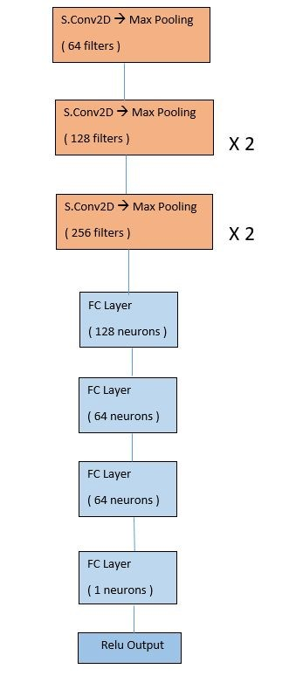

## 1.7 Motivation

Facial images are an important data source for many applications, such as face recognition, age/gender estimation, and emotion detection. The ability to accurately predict the age/gender of a person from a facial image can have a wide range of applications in automated customer service, marketing and advertising, video surveillance, medical diagnosis, and more. By using advanced deep learning techniques, it is possible to create powerful models that can accurately detect age/gender from a facial image. This could be used to generate more accurate customer profiles, improve customer service, and make automated decisions based on age and gender. Additionally, this could be used to detect security risks and fraudulent activities. In this project, we will explore the use of deep learning techniques to predict age/gender from facial images.

**CHAPTER 2**

## Literature Review

## 2.1 Description of Related Work

The work started by checking on a portion of the recently taken care of business in this field, in the type of perusing research papers. The papers gave an excellent understanding into the

field of Facial Socioeconomics as well as different strategies utilized by analysts to

tackle this difficult task.

|  |  |
| --- | --- |
| **Research Paper** | **Author(s)** |
| Face Recognition Performance: Role of Demographic Information | Brendan F. Klare, Mark J. Burge, Joshua C.  Klontz, Richard W. Vorder Bruegge, Anik K. Jain |
| Face Recognition and Age Estimation implications of Changes in Facial Features: A Critical Review Study | Rasha R. Atallah, Amirrudin Kamsin,  Maizatul A. Ismail, Sherin A. Abdelrahman, Saber Zerdoumi |
| Age estimation via face images: A Survey | Raphael Angulu |
| Convolutional Neural Networks for Age  Classification | Ari Ekmekji |

These papers talked about various strategies such as different ways of feature extraction such as Gabor filters, LBP, etc. that can be used with classical ML models. The papers also showcased the various CNN architectures used to solve the problem. They pointed out the importance of facial demographics for many applications such as facial recognition, age estimation etc. in numerous areas such as security, law enforcement, biometrics, forensics etc. and challenges involved such as pose, illumination, expression, aging, ethnicity, lifestyle, environment, databases, dataset.

**CHAPTER 3**

## Problem Definition

## 3.1 Title or problem selected

## Age & Gender Classification - ​ UTK Face dataset

It is a large-scale face dataset consisting of 20,708 face images. All images have annotations of age (0-116), gender (Male, Female), and ethnicity (White, Black, Asian, Indian, and Others). The images cover large variation in pose, facial expression, illumination, occlusion, resolution, etc.

## Age Estimation - ​ WIKI dataset​

It consists of 62308 images crawled from all profile images from pages of people​ from Wikipedia with the same meta information. In the Wikipedia dataset, the age labels were assigned by first removing the images without timestamp (the date when the photo was taken). Then, assuming that the images with single faces are likely to show the personality and that the timestamp and date of birth are correct, a biological (real) age was assigned to each such image.

Tracking of people provides a significant

Advantage to identification since we can apply the

Principle of continuity of identity [2]. This says that, while

we may only be able to identify a person occasionally

(such as when we have a good view of their face, when

they swipe an ID badge, or when they speak into a

Telephone), if wecan reliablytrack the person, we know

That all identifications associated with the track relate to

The same person and applythroughout the track. Several

(Fallible) identification methods applied at different times

And places can thus be combined and corroborated.

Tracking of people provides a significant

Advantage to identification since we can apply the

Principle of continuity of identity [2]. This says that, while

we may only be able to identify a person occasionally

(such as when we have a good view of their face, when

Tracking of people provides a significant

Advantage to identification since we can apply the

Principle of continuity of identity [2]. This says that, while

we may only be able to identify a person occasionally

(such as when we have a good view of their face, w

Tracking of people provides a significant

Advantage to identification since we can apply the

Principle of continuity of identity [2]. This says that, while

we may only be able to identify a person occasionally

(such as when we have a good view of their face, when

they swipe an ID badge, or when they speak into a

Telephone), if wecan reliablytrack the person, we know

That all identifications associated with the track relate to

The same person and applythroughout the track. Several

(Fallible) identification methods applied at different times

And places can thus be combined and corroborated.

**References:**

* Alexander, Rosebrock, A., Peng, Sam, Abraham, N., Wilf, . . . Seed, L. (2020, April 18). Keras: Multiple outputs and multiple losses. Retrieved June 11, 2020, from <https://www.pyimagesearch.com/2018/06/04/keras-multiple-outputs-and-multiple-losses/>
* Bansari, S. (2019, April 30). Introduction to how CNNs Work. Retrieved June 10, 2020, from <https://medium.com/datadriveninvestor/introduction-to-how-cnns-work-77e0e4cde99b>
* Chollet, F. (n.d.). The Keras Blog. Retrieved June 11, 2020, from <https://blog.keras.io/building-powerful-image-classification-models-using-very-little-data.html>
* Papers with Code - Age Estimation. (n.d.). Retrieved June 23, 2020, from <https://paperswithcode.com/task/age-estimation>
* Team, K. (n.d.). Keras documentation: Keras layers API. Retrieved June 25, 2020, from

<https://keras.io/api/layers/>